Placement
Student User guide
July 2023
Introduction 3
Create a new Placement record 3
Edit an existing Placement record 9
Documents 10
My Messages 10

Introduction

A placement is a period of work experience which is an integrated and assessed part of a student's degree. This includes any work or study-based experience that is part of a student’s programme and fulfils intended learning outcomes.

This document explains how to create and edit an existing placement record.

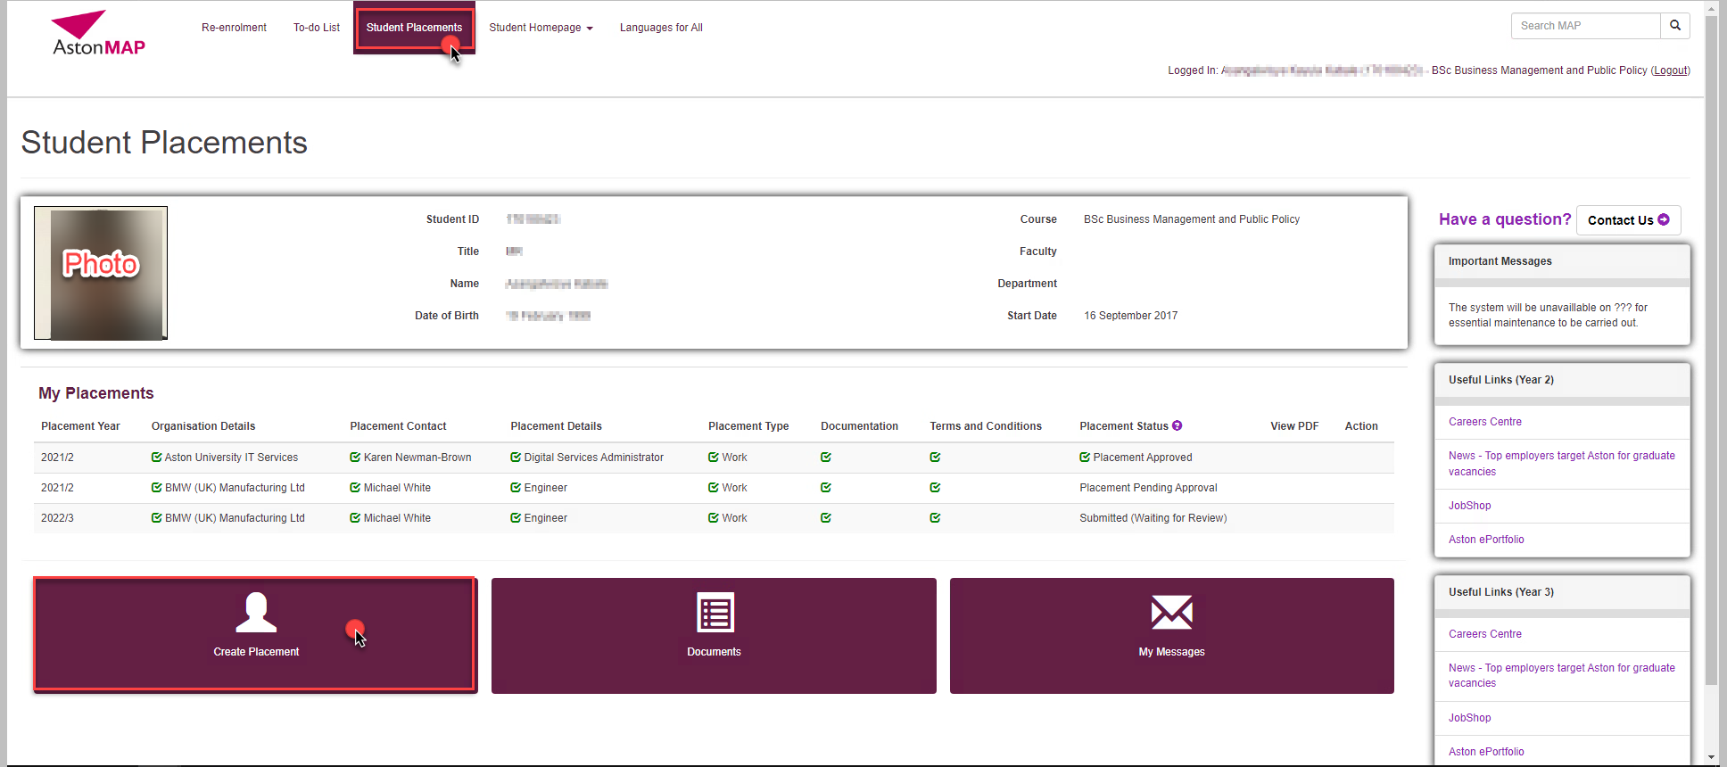

Create a new Placement record

- Click “Create Placement”
This will open the ‘Create Placement’ page to input the details.
Click each of the buttons to complete the application.
You can click ‘Save and Exit’ at any time during the process of the application.

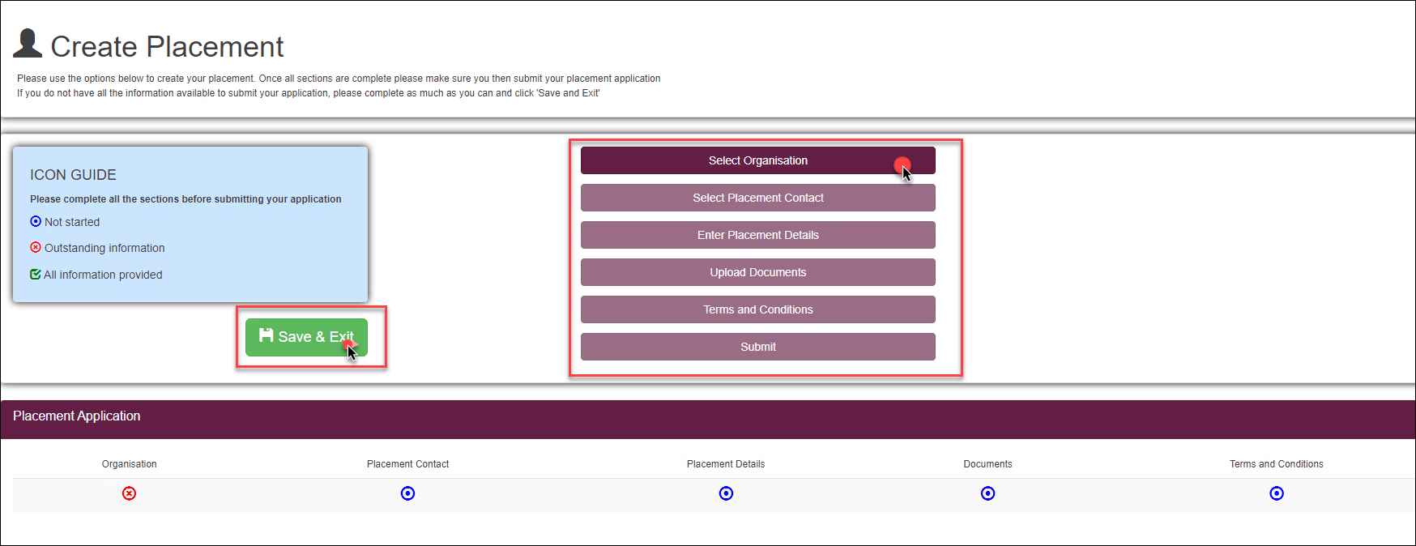

- Click to complete the Organisation details.
  - Input the below mandatory fields:
Field name | Description
Placement year | Choose the academic year from the dropdown
Placement UK/Abroad | Choose from In the UK or Outside the UK
Work/Study Placement | What is work based? Study based?
Organisation name | Input Organisation name, postcode or part of the address.
Create new | Create new if the Organisation name doesn’t exist in the system

  - If there are several organisations available, make sure the one you choose has the correct address and has the most completed fields.
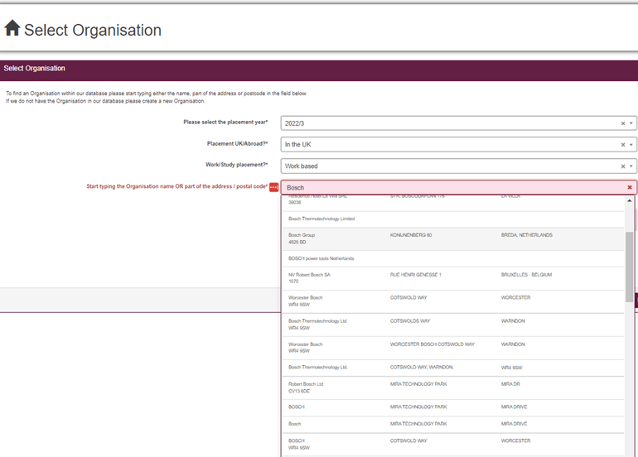

  - Click 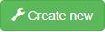 if the organisation does not exist in the system
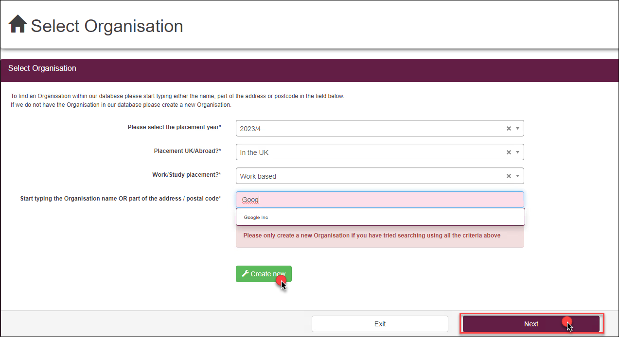
  - Click ‘Next’

You will notice in the ‘Placement Application’ bar the organisation has a green tick to indicate it’s complete.

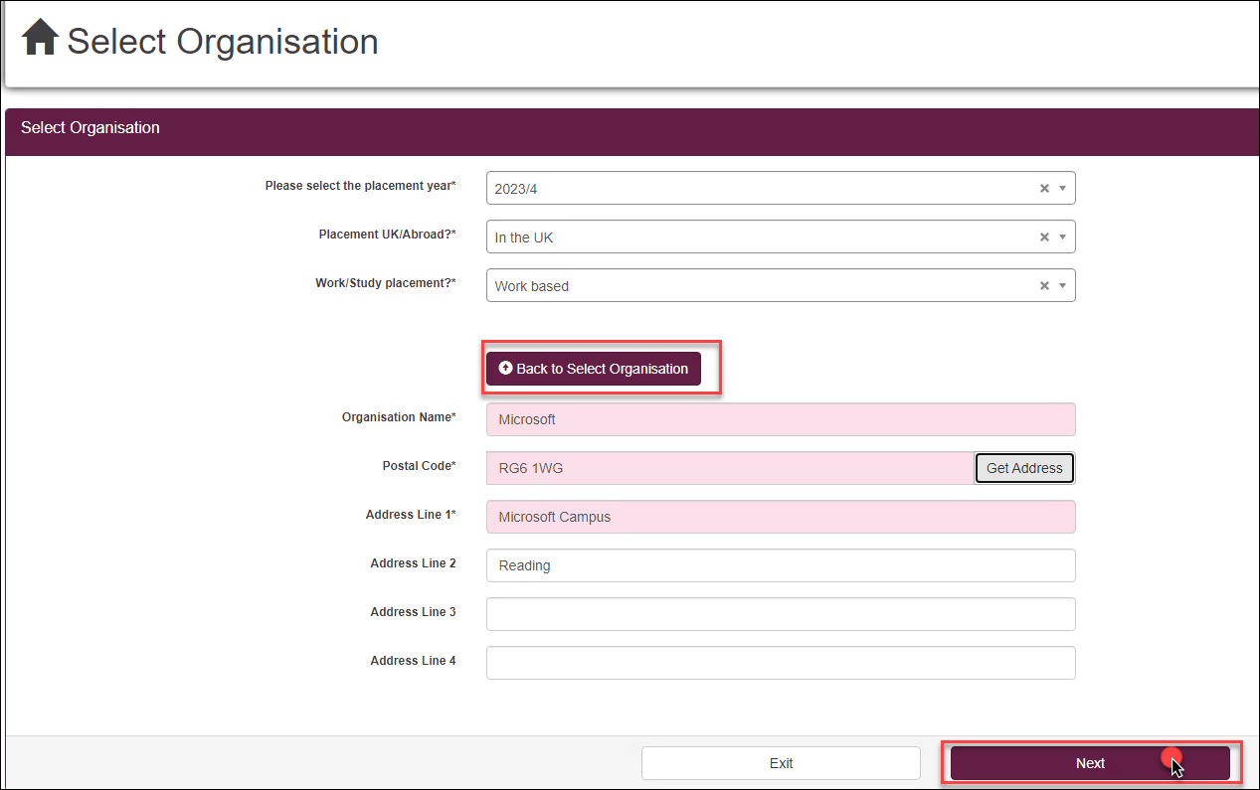

- Click to complete the placement contact details.

  - Choose contact name from the existing list provided in the drop down and check that all details are correct.
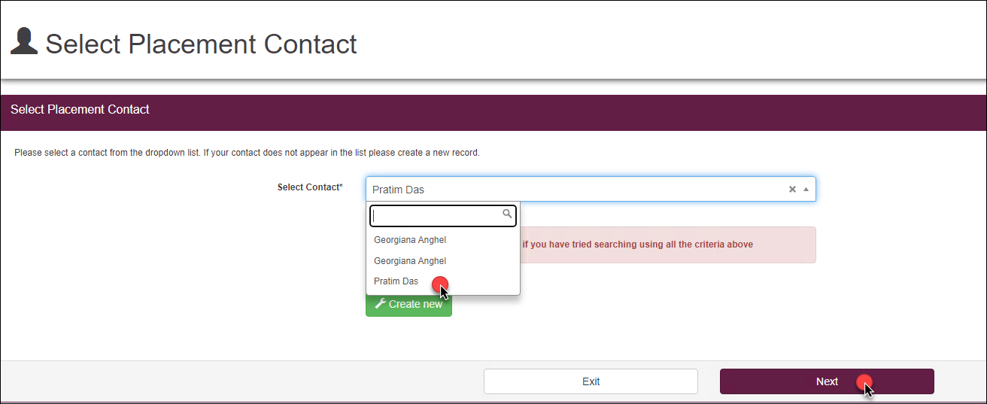

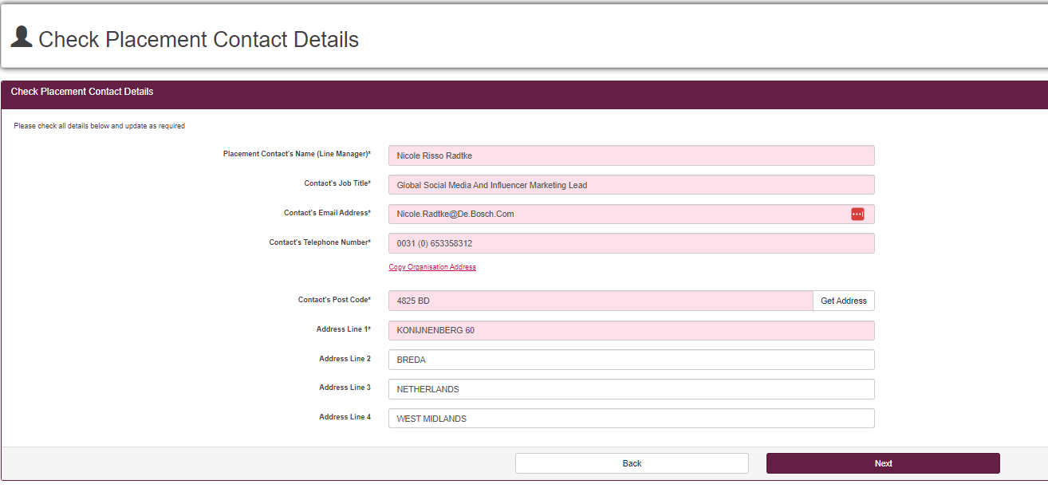
  - Click if the placement contact name does not exist in the system
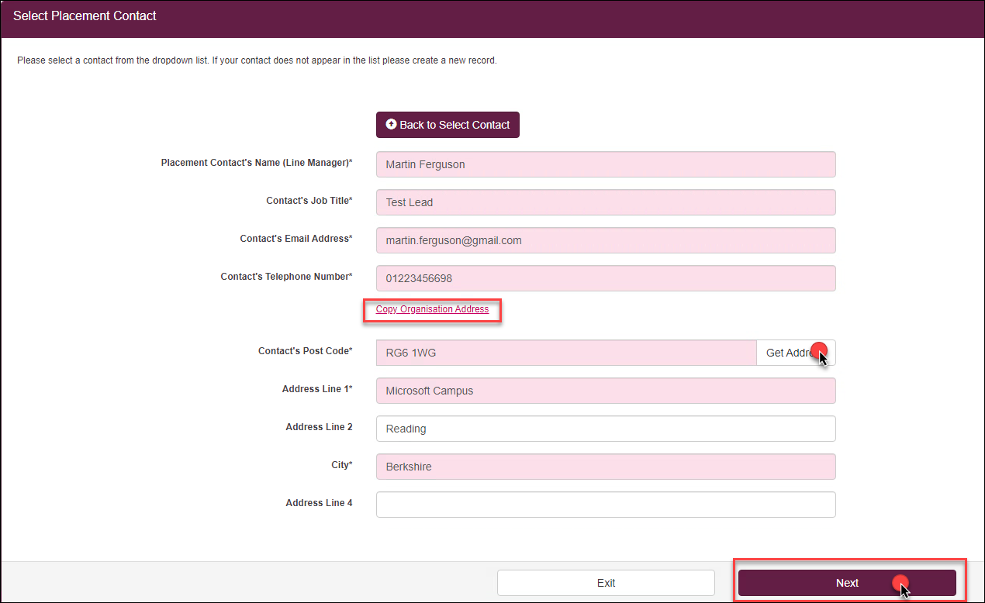
  - Click Next

You will notice ‘Placement Contact’ has a green tick to indicate it’s complete.

- Click to complete the Placement details.
Input the below fields

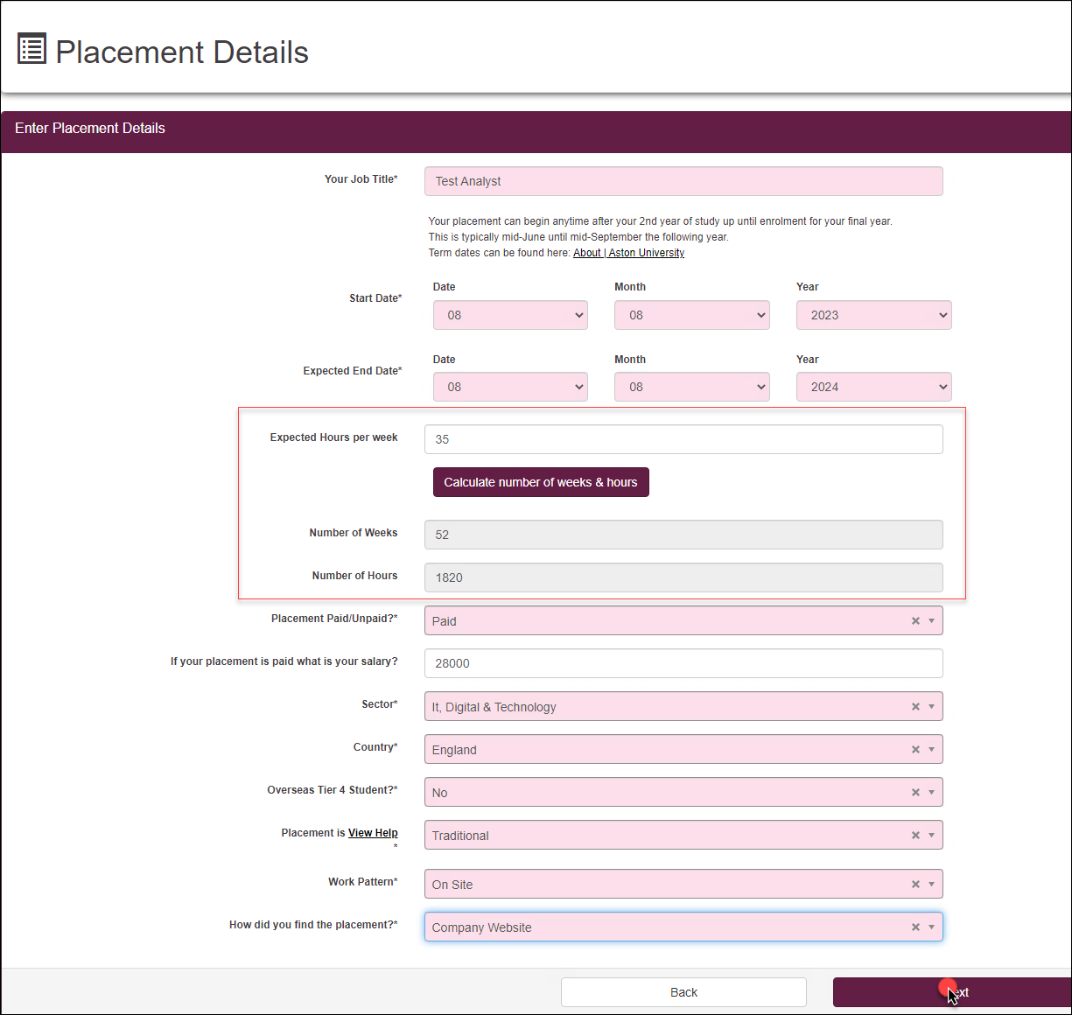

Field name | Description
Your Job Title | Input Job title
Start Date | Input Start date of the placement
Expected End date | Input end date of placement
Expected house per week | Input hours and click on the calculate number of weeks & hours button, below fields ‘number of weeks’ and ‘number of hours’
Placement Paid/Unpaid?* | Choose from the drop down:  - if paid then input amount in the drop down below  - If expenses, select unpaid, then expenses  - If unpaid, select unpaid, then voluntary
Sector* | Choose sector from the list
Country* | Choose the country from the list.  Please not there is no United Kingdom option, you should choose between England, Wales, Northern Ireland and Scotland.
Overseas Tier 4 Student?* | Choose yes or no from the drop down list
Placement is | Undergraduate student will only need to pick from the top 5 options  - Traditional: Typically graduate level roles, that can include placements with responsibility for people, projects or processes  - Flexible: Roles that are usually considered part time work or short term work experiences.  - Portfolio: Internally sourced placement activities that are usually supported by the Flexible Placements Team.  - Accelerator: Pilot programmes specific to college or course.  - Enterprise/BSEEN: Self-employment either with or without BSEEN programme
Work Pattern* | Choose from the list
How did you find the placement?* | Choose from the drop down list

  - Click Next

You will notice ‘Placement Details’ has a green tick to indicate it’s complete.

- Click to upload documents.
  - Click ‘Browse My computer’
  - Upload the documents.
Please note: minimum of 2 documents must be uploaded to submit the form

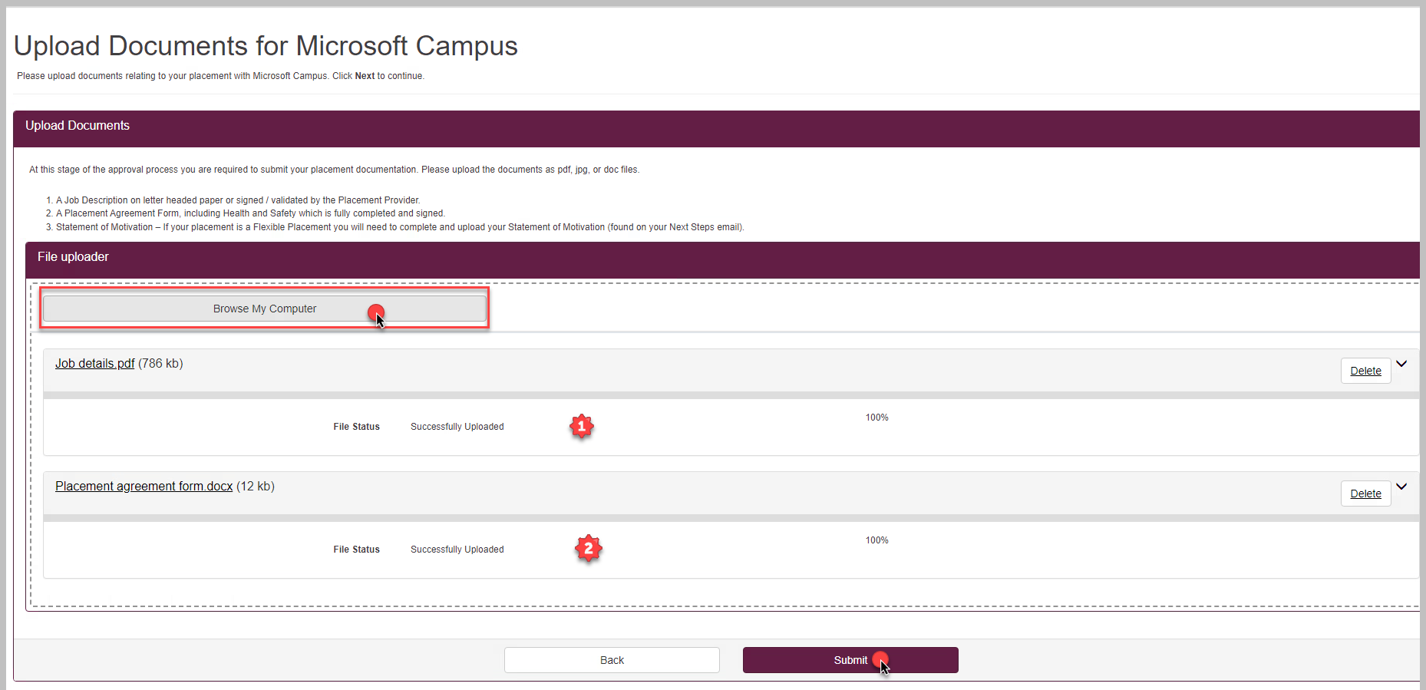

  - Click ‘Submit’

You will notice ‘Documents’ has a green tick to indicate it’s complete.

- Click
  - Use the box to indicate if you need any additional support whilst at placement
  - Tick the box to accept the terms and conditions

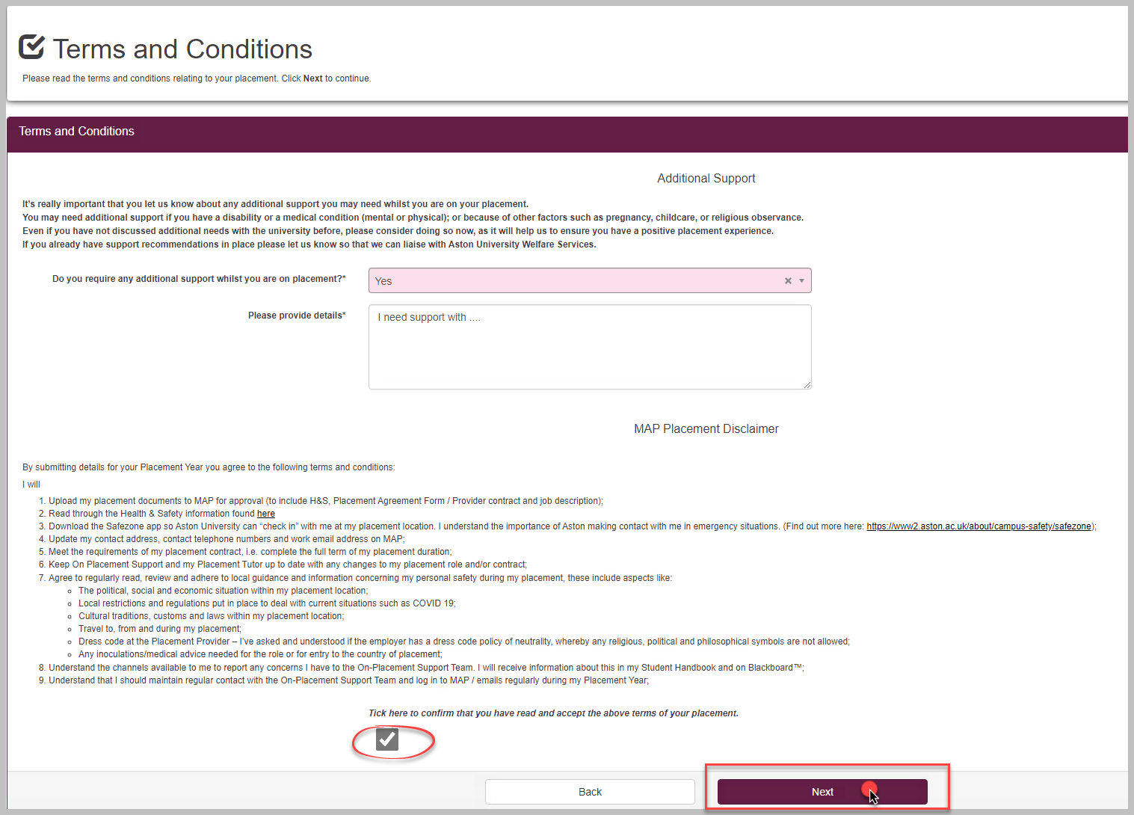

  - Click Next
You will notice ‘Terms and Conditions’ has a green tick to indicate it’s complete.

- Click to submit the application.

Edit an existing Placement record

- Select the relevant placement record and click ‘Continue’ from the existing list of placement records

- Follow the sections to complete your application, referring to the appropriate sections of the ‘Create new record’ guidance above
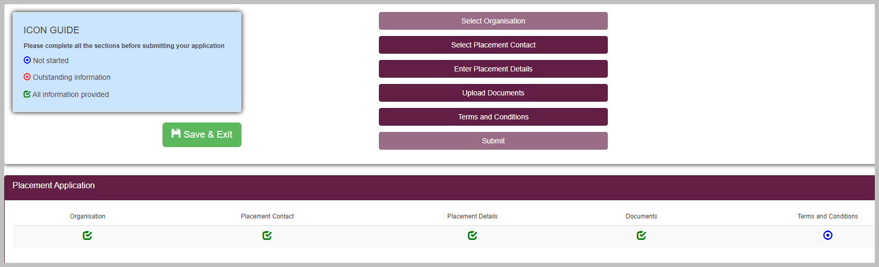

Documents

Displays a list of documents you have submitted.

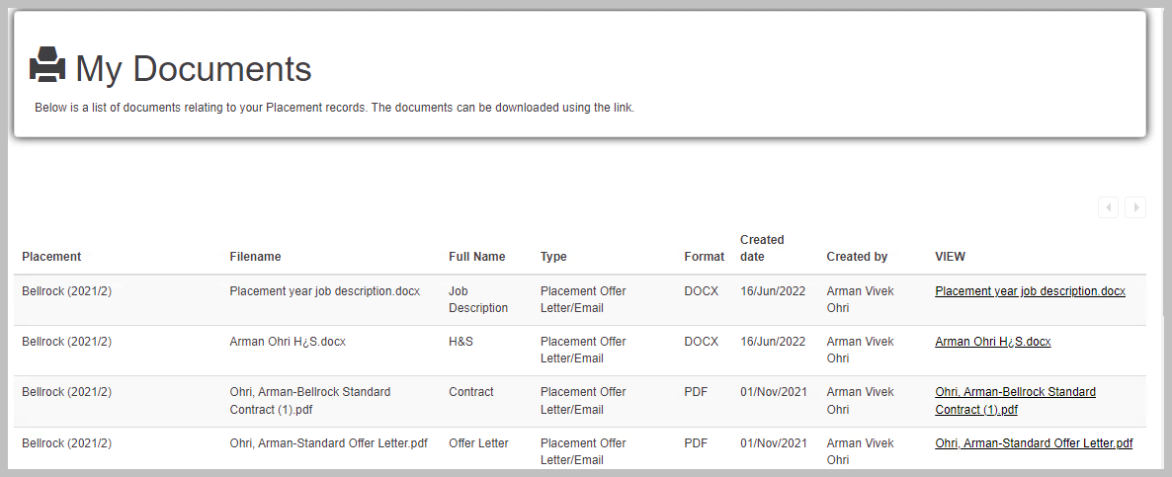

My Messages

Displays a list of messages received via MAP. While awaiting for a decision, check in this area and your email inbox regularly.
